DISCLAIMER: this is based on my extensive personal experience with Public Transport Victoria and the information below is what I, Yeung-ae Park, believe is true as of May, 2015. Any changes in the system may be possible since, so please check out the official website if any confusion is caused or for any confirmation.

Public transport guide
Website: http://ptv.vic.gov.au/
How to get from A to B: http://ptv.vic.gov.au/journey#jpsearch%5Baction%5D=showPlanner (Journey Planner)
Next 5 departures: http://ptv.vic.gov.au/next5

Basics:
You need a MYKI card to travel. They are available in full fare or concession.
Concession allows a discount (half price of full fare) for those who are eligible. International students were previously not eligible for concession no matter in what level of education, however from 2015, PTV (public transport Victoria) is running a 3 year trial of a concession rate for international UNDERGRADUATE students with terms & conditions (can only get concession rate if you buy for the whole year pass than a daily concession). In short, unfortunately, international POST GRADUATE students (MD students) are not eligible for concession and must have a full fare Myki card to travel.

Myki:
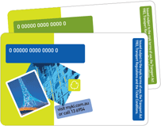
You MUST have a Myki card to travel unless you’re in the free tram zone or on the City Circle tram, which is also free. Myki can be purchased at a cost under $10 at most train stations or even at some convenient stores. Just be aware that these cards do have an expiry date and you need to update them every few years.

Myki is not a number based but a time based system (i.e. it doesn’t matter if you ride the train 10 times, but it does matter if you travel within 2 hours or over).

Every time you get on a bus, tram or train; you TOUCH ON. Every time you get off, you TOUCH OFF (however PTV does say you don’t need to touch off when you get off the tram). You can also register your Myki online so that you can claim for another Myki if you Myki is stolen or lost (especially relevant if you had lots of credit on it).

The rates are simple:

- If you travel within ~2 hours of your first “touch on”, you pay the 2 hour rate
- If you travel outside the ~2 hours of your first “touch on”, you pay for the whole day.
There’s a little trick to it. If you touch on at 1.59pm, your end of ‘2 hour’ is at 4pm (rounded up). However, if you touched on at 2.01pm, your ‘2 hour’ will be rounded up to 5pm.
Another handy trick is if you touch on past 6pm, that ‘2 hour’ fare should cover you until 3am the next day!

Myki Money
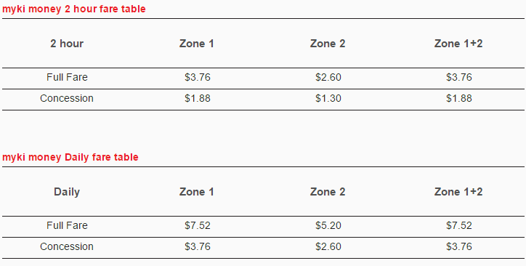
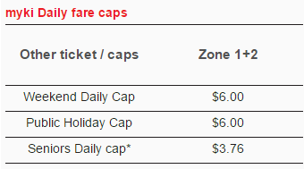

Myki Pass (cheaper daily rate than Myki Money)
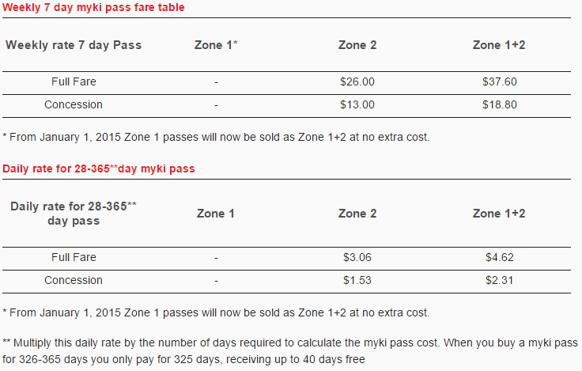
You can either travel with Myki MONEY or Myki PASS. Myki Money is recommended for infrequent travelers, as you only pay when you need to as you touch on and off. Myki Pass is recommended for frequent travelers, as you pay up front for a period of time for a cheaper daily rate.
Weekends have a cheaper rate of $6.00 maximum in the day, after the same charge of 2 hour rate.
Early bird train travel: Touch on and off at train stations on Melbourne’s electrified train network before 7am on a weekday and automatically receive the free Early Bird fare

Zones:
There are multiple zones (1; metropolitan, 2; outer suburbs) in Melbourne. Prior to 2015, you paid more for crossing over zones (e.g. zone 1+2 was nearly double the price of zone 2 itself), however, the rate of Zone 1+2 is equivalent to Zone 1 since 2015, making distant travelling more affordable. Travelling within zone 2 alone is however cheaper than travelling alone in zone 1 (or zone 1&2 as now they’re equivalent).

Free tram zone:
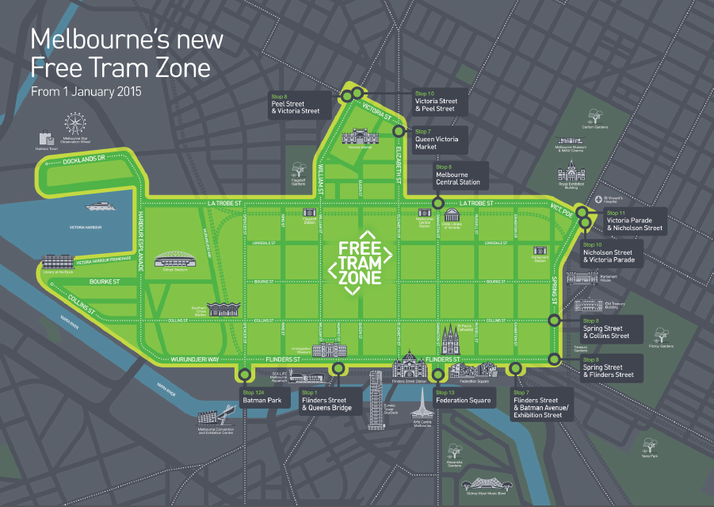
Completely free to travel within this area without a valid Myki. However, make sure you touch on before/as soon as the tram is outside the free tram zone, as undercover ticket inspectors can check on you! Don’t worry about not having memorized the map – there are signs at each tram stop, noting if they’re inside or outside the free tram zone and the trams make automatic announcements when you’re approaching the border of free tram zone.

City Circle:
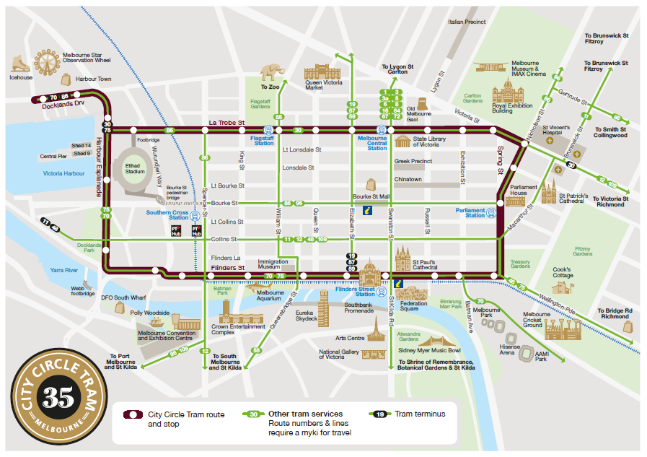
Also a free tram and great for travelers. The tram driver briefly talks about the places the tram goes past.

When going out to the country:
V lines are the trains that go outside metropolitan areas and will deliver you to the country sites. For travelling further distance, you consequentially pay more, but it is automatically calculated when you touch on and off. Tickets are always checked for on the V lines.

City loop:
Consists of Flagstaff, Melbourne Central, Parliament and Southern Cross. Depending on the time of the day, the train may go to Flinders St via City Loop or directly to Flinders St and then on its return, pass via City Loop.

Ticket inspectors:
It is important to have your ticket valid at all times (not necessary in the FREE city tram zone), as inspectors can ask you to show them your ticket any time. They may be dressed as inspectors, usually travelling in groups or may be undercover, dressed in casual clothes. Fines can be paid either as a significantly smaller amount at the time of confrontation or pay much more at a later time when you’re billed.

Useful apps:
- Tram Tracker
- PT Victoria

Relevant maps
Tram map:
http://ptv.vic.gov.au/assets/PDFs/Maps/Network-maps/Tram-Network.pdf
Train map:
http://ptv.vic.gov.au/assets/Images/maps/Network-maps/PTV_Train-Network-Map_10Oct2014.pdf

